Report

Sharks and Rays Data Collection

CAMBODIA

Period: September 2015 to August 2016

Fisheries Administration, August 2016
Contents
1.0 INTRODUCTION 1
1.1 Objective 1
1.2 Data Collection at Landing Sites 1
1.2.1 Selection of Study Sites 1
1.3 Appointment of Enumerators 3
1.4 Materials and Methods 3
1.4.1 Sampling Methods 3
1.4.2 Selection of Fishing Vessels and Sampling Activities 4
1.4.3 Classification 4
2.0 RESULTS 4
2.1 Site BAP Jetty 4
2.1.1 Landing Samples 4
2.1.2 Fishing Ground and Catch Composition 5
2.1.3 Sharks and Rays Composition 7
2.1.4 Sample Size 7
2.1.5 Weight of Sharks and Rays by Species 8
2.1.6 Size Range of Sharks and Rays 10
2.1.7. Fishing Effort and CPUE (Catch per Unit Effort) 14
2.1.8 Usage and Marketing 16
3.0 CONCLUSION 17
4.0 OUTPUT AND OUTCOME 19
5.0 FUTURE ACTIVITIES 20
References 21

Tables
Table 1: Number of Licensed Fishing Vessels and Number of Fishers 3
Table 2: Landings Sampled During the Study at Fishing Ground 4
Table 3: Weight of Sharks and Rays (in kg) 6
Table 4: Catch Composition of Sharks, Rays, Commercial and Low-value Species (LVS) by Month from September 2015 to August 2016 at Tumnup Rolok. All Weights in Kilogram 7
Table 5: Sample Size of Sharks and Rays by Species 8
Table 6: Weight of Sharks and Rays (in Kg) by Species from BEP landing site 9
Table 7: Size Range of Sharks (Total Length) and Rays (Disc Length) Except for Aetobatus ocellatus, Carcharhinus melanopterus and Carcharhinus sorrah (Total Length) from September-December 2015. All Measurements in cm. 11
Table 7B: Size Range of Sharks (Total Length) and Rays (Disc Length) Except for Aetobatus cf ocellatus (Total Length) from January-August 2016. All Measurements in cm. 12
Table 8: Days at operation by gears sampled during the study period 2015-2016 14
Table 9(1): CPUE shark species captured by Trawl Net (catch (kg)/Fishing Effort) 14
Table 9(2): CPUE Ray species captured by Trawl Net 15
Table 9(3): Top 6 CPUE shark species captured by Trawl Net during the study period (number of individuals/Fishing Effort) 15
Table 9(4): Top 7 CPUE ray species captured by Trawl Net during the study period (number of individuals/Fishing Effort) 16
Table 10: Total days of operation by gears during the study period 16
Table 11: Price of Sharks and Rays by Species the Landing Site 17
Table 12: Output and Outcome 19

INTRODUCTION
Cambodia has 435 Km coastlines in the Gulf of Thailand, which is stretched between Vietnamese borders in the south to Thai border in the west. There are four (4) provinces located along this coastline namely, Koh Kong (237 Km), Preah Sihanouk (105 Km), Kampot (67 Km) and Kep (26 Km) provinces. There are 525 species of marine finfish, 20 species of marine crabs, 42 species of marine gastropods, 24 species of marine bivalves and 11 species of marine mammals (Tana 1997, Try 2003). Furthermore, the Kingdom of Cambodia has her own Exclusive Economic Zone (EEZ), the area extended from the shoreline to 200 nautical miles, which covers 55,600 Km². Marine fisheries of Cambodia are definitely pelagic due to the physical feature of the EEZs area (Maximum depth is not higher than 80 meters), and their productivity covers around 20% of national fish production. The introductions of modem fishing technologies were appeared around 1958s.

Fishing practices in Cambodia are classified three (3) types namely small-scale or family fisheries medium-scale and commercial-scale. The commercial-scale and middle-scale fisheries refer to those fishing activities that highly efficient fishing gears and have capacity to fish offshore and inshore using all fishing gears with exception of trawling in inshore waters. The official fisheries statistic of the Fisheries Administration has not been categorized by species but by higher taxonomy such as fish, shrimp, ray, squid, crab, snail, and mussels. In general, small pelagic fish have been classified by species (short mackerel and Indian mackerel), based on group of fish (round scads); and other group of fish by market size, while pelagic fish size was not fit to market size that was considered as trash fish. These species are usually caught by long-tailed boats applied with gill nets, and purse seine net vessel either in shallow or deep waters.

Additionally, SEAFDEC started to support Sharks/Rays data collection and data analysis for one year, beginning from September 2015 to August 2016.

1.1 Objective
The objectives of this project were:

- To enhance human resource development in elasmobranch taxonomy, and
- To improve landing data recording from generic ‘Sharks’ and ‘Rays’ to species level.

1.2 Data Collection at Landing Sites
Preah Sihanouk Province is a major landing areas for sharks and Rays

1.2.1 Selection of Study Sites

Tomnup Rolork,Phum III,Sangkat I Preah Sihahouk City, Sihanouk Province consists of four (4) main landing areas where selected as the project sites. BEP jetty was selected for data colection. This landing site owns by private sector. The most of Sharks and Rays catch production come from trawlers, long lines and seine nets. The trawler was seclected as the representative gear for data

collection. The project site as reveals in Figure 1.
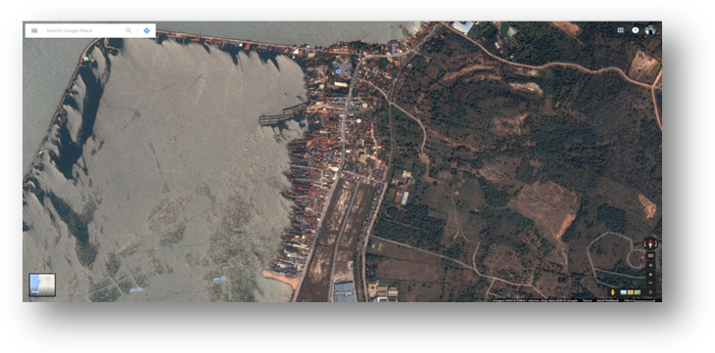

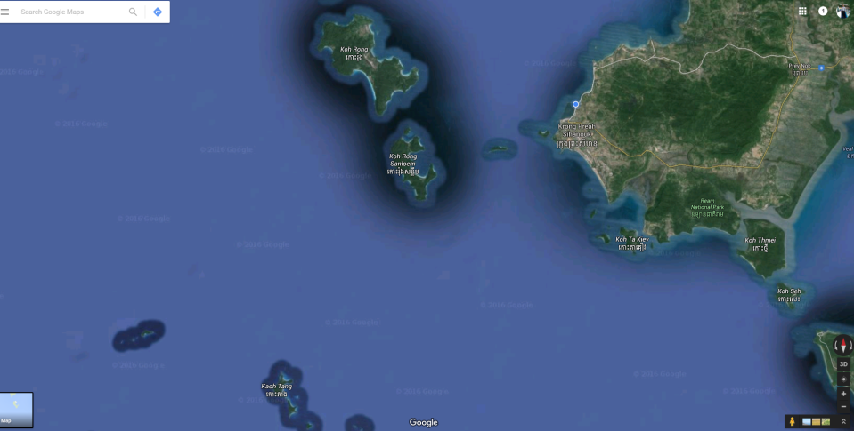
Figure 1. Map of tracking of BBO (0001-0003) vessel, Sihanouk ville

Figure 2. Map of tracking of BBO (0001-0004) vessel, Sihanouk ville

1.2.1.1 Fishery Structure and Background of Study Sites

1.2.1.2 Site (Tomnup Rolork BEP Jetty)
Preah Sihanouk is one of the major province where comprises more landing sites for Sharks and Rays among the coastal provinces of Cambodia. All jetties belong to private owners. The major gear was trawl nets. Numbers of crew working on boat depend upon volume of the vessel which vary from 3-8 crew members. Almost all Sharks and Rays were landed by trawlers, between 8-57 nautical miles from the coastline and 8-25 meters depth (As in Table 1). Fishing operation between 1-15 days per trip and 3-4 times per haul. All catches were landed from 6-10 in the morning.

Table 1: Number of Licensed Fishing Vessels and Number of Fishers

1.3 Appointment of Enumerators
Mr. Ly Seyha, fisheries officer from Marine Aquaculture Ressearch and Development Center (MARDeC) was appointed as enumerator. His contact detail as follow:

Mr. Ly Seyha
Acting Chief of Aquaculture Technology Feed and Water Quality
Group 12, Village 3, Sangkat 1, Preah Sihanouk town,
Preah Sihanouk province

1.4 Materials and Methods

1.4.1 Sampling Methods
The sampling activity started on 10 September 2015 until 12 August 2016. The enumerator was requested to record landing data and other related information in a standard form at least 5 days/month. A standard SOP entitled ‘SOP Sharks and Rays Data Collection in the Southeast Asian Waters’ was produced. The content included Standard Operation Procedure and instructions to enumerators on how to measure, weight, record Sharks and Rays species at sampling sites, name of enumerator, name of landing site, date of sampling, vessel registration number, vessel Tone, fishing area, price at landing sites, name of species (common name and scientific name), total catch of Sharks, Rays, commercial and low-value species from each sampling vessel. The details of the standard form is shown in Appendix I. The completed data in excell were submitted to the respective Sharks and Rays Focal Point before submitted to SEAFDEC every month for verification. The data were analysed at the end of the month.

1.4.2 Selection of Fishing Vessels and Sampling Activities
Between 2-3 fishing vessels were selected for sampling each day for 5 days per month at the landing site. Measurement of Total length (TL) was taken for all Sharks and Rays species from five (5) species of Shark: Atelomycterus marmoratus, Carcharhinus sorrah, Carcharhinus leucas, Carcharhinus melanopterus, and Chiloscyllium punctatum and six (6) species of Ray: Aetobatus ocellatus, Dasyatis parvonigra, Dasyatis zugei, Himantura imbricata, Himantura walga, and Taeniura lymma.
All Sharks and Rays specimens were measured and weighed individually depends on the actual weight in a day. The maturity stage for each individual was estimated according to Yano et al. (2005) and Ahmad and Annie Lim (2012). The total catch of all Sharks and Rays by species as well as the total catch of commercial and low-value species were also recorded for each sampling vessel. Larger specimens were photographed, and identified species and biological characteristics.

1.4.3 Classification
The classification (scientific names) used in this report follows that of Compagno (1999), Yano et al. (2005), Ahmad and Annie Lim (2012), Ahmad et al. (2013) and Ahmad et al. (2014), and Ebert et al. (2013).

RESULTS

2.1 Site BEP Jetty

2.1.1 Landing Samples
Only one landing site named BEP was sampled during the study period. The reason that salected this site because that is the largest site and the most variety vessels landed in this jetty. The peak month was 16 days in June 2016 and nine (9) months falled in the same number, 15 days namely October, November, December 2015 and August, January, February, March, April, and May 2016 respectively operating in eight (8) fishing gronds. The only two (2) months were collected 28 days (14 days each) in September 2015 and July 2016 (Table 2).
Table 2: Landings Sampled During the Study at Fishing Ground

2.1.2 Fishing Ground and Catch Composition
Trawl net is the main gear for Sharks and Rays data collection at 13,901.5 kg (100%). The amount of Rays collected at the same landing sites and fishing grounds was lower weight (5,374.0 kg) compared to Shark weight was 8,527.43 kg. Table 3 illustrated that Koh Tang was the main fishing ground where longer distance and deeper depth-could be collected highest weight for both Shark and Ray, 3944.7 kg and 6533.6 kg respectively for commercial-scale (The detail is shown in Table 3).
Table 3: Weight of Sharks and Rays (in kg)

2.1.3 Sharks and Rays Composition
A total of 912,301.94 kg of fish was landed from BEP jetty during the study period. Sharks and Rays made up 8,527.43 kg and 5,379.57 kg (11.01% and 7.20%) from the total landing respectively. While landings of commercial and low-value species were 707,183.94 kg and 191,211 kg or 77.52% and 20.96% respectively. Average landings per month for Sharks and Rays were 710.62 kg and 448.27 kg respectively. The highest landing by month for Rays was 963 kg in February 2016, followed by 612 kg in January 2016 and 577 kg in March 2016. However, the highest landing for Rays was 963 kg in February 2016 followed by 612 kg in January 2016 and 577 kg in March. In general, the landing of Sharks and Rays ranged between 0.47-1.19% and 0.35-1.20% respectively from total landing. The details are shown in Table 4.

Table 4: Catch Composition of Sharks, Rays, Commercial and Low-value Species (LVS) by Month from September 2015 to August 2016 at Tomnup Rolork. All Weights in Kilogram.

2.1.4 Sample Size
A total of 1,876 belonging to 957 Rays and 919 Sharks were sampled comprising six (6) species of Rays and five (5) species of Sharks. The most abundant Ray species were Himantura walga followed by Himantura imbricata and Dasyatis zugei. The highest number of Rays sampled by month was 99 in October followed by 98 in November and 84 in December 2015. The most abundant Shark species was Chiloscyllium punctatum (710 head) while the scarce species was Carcharhinus sorrah (1 head). However, the highest number of Sharks sampled by month were 93 in November, followed by 85 in December and 84 in October 2015. The most common Ray species were Himantura walga followed by Himantura imbricata and Dasyatis zugei, while the most common shark species were Chiloscyllium punctatum and Atelomycterus marmoratus. All these species were landed all year around. Other species such as Aetobatus ocellatus, Taeniura lymma, Carcharhinus sorrah, Carcharhinus leucas, Carcharhinus melanopterus, were rarely landed and only landed between 1-4 months during the study period (Table 5).

Table 5: Sample Size of Sharks and Rays by Species

2.1.5 Weight of Sharks and Rays by Species
A total of 1, 3901.81 kg was landed from BEP landing site comprising 5374.38 kg Rays and 8527.43 kg Sharks. For Rays, the highest landing by weight was from Himantura walga amounting to 1900.75 kg with the highest amount of landing by month was 265.98 kg in (July) 2016 and the lowest landing at 20.30 kg in September 2015 for Himantura walga. The common landing species of Ray were Aetobatus ocellatus (239.40 kg), Himantura imbricate (1247.51 kg), Dasyatis zugei (1058.96 kg), and Dasyatis parvonigra (912.76 kg). The lowest amount and the rarest species landed was Taeniura lymma (3.57 kg). The highest landing of Shark species was 7282.17 kg Chiloscyllium punctatum and 878.77 kg Atelomycterus marmoratus. The order species range from 63.64 kg - 65.64 kg. The highest landing by month for Chiloscyllium punctatum was 1171.92 kg in February 2016 followed by 1083.35 in December2015 , and 797.08 kg in March 2016. For Atelomycterus marmoratus, the highest landing was 281.12 kg in January 2016, followed by 137.08 kg in February 2016,136.92 kg in March 2016. The details are shown in Table 6.
Table 6: Weight of Sharks and Rays (in Kg) by Species from BEP landing site

2.1.6 Size Range of Sharks and Rays
Most Ray species sampled from September to December 2015 and January to August 2016 were mature except Aetobatus ocellatus, and Taeniura lymma. The average size of Aetobatus ocellatus ranged between 84.0-90.0 cm disc lengths. First maturing size for Aetobatus ocellatus is about 30.0 cm, for Dasyatis parvonigra about 19.0 cm disc length, Dasyatis zugei about 18.0-22.0 cm disc length, Himantura imbricata about 18-21 cm disc length, Himantura walga about 17-20 cm disc length, and Taeniura lymma disc length. All these Ray species were caught under mature stage at 12 cm disc length for Dasyatis parvonigra in September, 13 cm disc length for Dasyatis zugei and Himantura imbricate in September and October, 11.60 cm disc length for Himantura walga in October. Most of shark species landed were mature except for Carcharhinus sorrah, Carcharhinus melanopterus. First maturing size of Atelomycterus marmoratus, Carcharhinus leucas, Chiloscyllium punctatum are 40.0 cm, 70.0 cm and 50.0 cm total length respectively. For Shark species, the only Chiloscyllium punctatum was caught under adult stage at 28.50 cm in September, 19.50 cm in October, 18 cm in December, 29 cm in January, and 12 cm in March. Size range of all Sharks and Rays species from September to December 2015 are shown in Table 7A and Table 7B.

Table 7A: Size Range of Sharks (Total Length) and Rays (Disc Length) Except for Aetobatus ocellatus, Carcharhinus melanopterus and Carcharhinus sorrah (Total Length) from September-December 2015. All Measurements in cm.
 | 2015
 | September |  |  | October |  |  | November |  |  | December
Species/cm | Max | Min | Ave | Max | Min | Ave | Max | Min | Ave | Max | Min | Ave
Ray | 84 | 12 | 20.07 | 27.5 | 11.6 | 18.61 | 90 | 15 | 19.97 | 26 | 14 | 19.48
Aetobatus ocellatus | 84 | 84 | 84.00 |  |  |  | 90 | 90 | 90.00
Dasyatis parvonigra | 29.5 | 12 | 18.48 | 27.5 | 18 | 20.21 | 21 | 17 | 19.61 | 26 | 14 | 19.50
Dasyatis zugei | 27 | 13 | 18.32 | 21 | 15 | 18.62 | 25 | 15 | 19.20 | 25 | 16 | 20.29
Himantura imbricata | 30 | 13.5 | 19.97 | 21 | 13 | 18.11 | 23 | 16 | 19.04 | 22 | 17 | 19.38
Himantura walga | 45 | 13.5 | 19.84 | 22 | 11.6 | 18.34 | 28 | 16 | 19.25 | 22 | 16 | 19.15
Taeniura lymma |  |  |  | 27.5 | 27 | 27.25
Shark | 92 | 28.5 | 54.66 | 103 | 19.5 | 52.64 | 84 | 30 | 56.89 | 86 | 18 | 57.74
Atelomycterus marmoratus | 53.5 | 44.5 | 49.83 | 53 | 33 | 44.08 | 64 | 32 | 44.71 | 61 | 35 | 45.81
Carcharhinus leucas | 74.1 | 74.1 | 74.10
Chiloscyllium punctatum | 92 | 28.5 | 54.84 | 103 | 19.5 | 54.98 | 84 | 30 | 61.13 | 86 | 18 | 60.51

Table 7B: Size Range of Sharks (Total Length) and Rays (Disc Length) Except for Aetobatus ocellatus (Total Length) from January-August 2016. All Measurements in cm.

2.1.7. Fishing Effort and CPUE (Catch per Unit Effort)
Trawl net fishing gear for Sharks and Rays divided by three types: 1) Trawl Net Commercial Scale, 2) Trawl Net Medium Scale, and 3) Trawl Net Small Scale. Data collection of trawl boat was collected randomly. In actual practice, trawl net commercial scale found more numbers (1,351) compared to medium (310) and small (121) scales. For the commercial scale, there were 148 days of operation in December 2015, followed by 144 days of operation in November 2015 and 131 days of operation in April 2016. The enumerator did not meet trawl net medium scale for three (3) months (in November, December 2015, and January 2016), and small net medium scale for one month (in July 2016) (Table 8).
Table 8: Days at operation by gears sampled during the study period 2015-2016

Table 9 (1) revealed that the catch per unit effort of Shark species, Chiloscyllium punctatum got high total weight at 7282.169 kg, followed by Atelomycterus marmoratus at 878.767 kg which weight per day at operation was 4.083 and 1.023, weight per number of operation was 0.009 and 0.0009, and weight per swept area was 12.050kg/km² and 0.1101kg/ km², respectively. For weight of number of operation of Carcharhinus sorrah and Carcharhinus leucas fell the same, 0.0002; likewise Carcharhinus sorrah and Carcharhinus melanopterus was 0.0001. The total weight for other species ranged from 4.42 to 17.12 (Table 9 (1)).
Table 9 (1): CPUE Shark species captured by Trawl Net (catch (kg)/Fishing Effort)
CPUE of weight per days at operation, weight per numbers of operation, and weight per swept area vary up on the total weight of Ray species. The total weight of Himantura walga Ray species was high, 1900.746 kg, while Aetobatus ocellatus, Himantura imbricata, Dasyatis zugei, and Dasyatis parvonigra were 67 kg, 58.8 kg, 53.27 kg, 47.387 kg, and 40.86 kg, respectively. The weight per days at operation of these species ranged from 0.0019 to 0.0545, weight per numbers of operation started 0.0000 to 0.0014 to 0.1693, and weight per swept area ranged from 0.0059 to 0.1693 (Table 9 (2))
Table 9 (2): CPUE Ray species captured by Trawl Net

Table 10: Total days of operation by gears during the study period
Type of Fishing Gear | 2015 |  |  |  | 2016 |  |  |  |  |  |  |  | Total
Type of Fishing Gear | S | O | N | D | J | F | M | A | M | J | J | A | Total
Trawl Net | N/A | N/A | N/A | N/A | N/A | N/A | N/A | N/A | N/A | N/A | N/A | N/A | N/A
Note: Total days of operation by gear in Cambodia is not applicable.

2.1.8 Usage and Marketing
Information on marketing collected at this landing site revealed that most Sharks and Rays were consumed locally and some were exported to Viet Nam. The major markets were Phnom Penh Capital city. The price varied not much among the six (6) species. The most expensive Ray Himantura imbricate and Himantura walga were sold around USD 1.5-3.2/kg followed by Aetobatus ocellatus around USD 2-3/kg and Taeniura lymma around USD 1-3/kg. The other Ray species such as , Dasyatis parvonigra, and Dasyatis zugei price ranged from USD 1-2.5/kg. In general, bigger size Rays were more expensive than smaller ones.
Small sized Sharks with total weight of less than 3 head/kg head were sold locally at USD 2/kg. The most expensive Sharks Carcharhinus leucas was at USD 2.5-4/kg, and Carcharhinus melanopterus sold at USD 2-4/kg, Carcharhinus sorrah at USD 2.5-3.75/kg, Atelomycterus marmoratus and Aetobatus ocellatus at USD 1.75-3.75/kg, Carcharhinus sorrah at USD 2.75-3.75/kg. The cheapest price was Chiloscyllium punctatum at USD 1.75-3.3/kg. Market destinations for sharks and rays were the same.
Normally the suppliers use track to deliver Shark and Ray to the other markets for local consumption in the morning after landed. However, the distribution of Shark and Ray to Viet Nam transported by land and ships (cargo vessels). The price of exported product was higher than local consumption, both Shark and at UDS 3-4/kg. The details are shown in Table (11).Small, medium and big sizes category for each species is as shown in Appendix XXX

Table 11: Price of Sharks and Rays by Species the Landing Site All Prices in USD per Kilogram.

CONCLUSION
A pilot project on recording landing data of Sharks and Rays up to species level was conducted in Tumnup Rolok of Preah Sihanouk province. During this project, three (3) officers of Marine Aquaculture Research and Development Center (MARDeC), and one officer of Kampong Som Fisheries Administration Cantonment were trained in taxonomy and in data collection using the new harmonized format. One landing site (jetty) namely BEP was selected as the study site as it was the main landing site of Sharks and Rays in the province.
A total of five (5) species of Sharks from two (2) Orders and three (3) Families, and six (6) spesies of Rays from one (1) Order and two (2) Families were recorded. Details are shown in Appendix II. In term of percentage of total marin landings, Sharks and Rays only contributed 21.68% and 0.60% at Preah Sihanouk province. These figures confirmed earlier data as published in Cambodian National Statistics that shark was by catch and not targeted and contributed about 39.41% of the total Shark caught by weight. Ray was not recorded in the National Statistic before.
The most abundant Shark species was Chiloscyllium punctatum and for Ray Himantura walga. The most common Shark species were Atelomycterus marmoratus and Chiloscyllium punctatum, while Rays were Aetobatus ocellatus, Himantura imbricata, Dasyatis zugei, and Dasyatis Parvonigra .The size of Shark which more than 103 centimetres in total length was Chiloscyllium punctatum and medium sized Sharks were Carcharhinus sorrah and Carcharhinus leucas was rarely caught due to nature of fishing area and gear used. Sharks and Rays production distributed to domestic consumption and exportation.

OUTPUT AND OUTCOME
(Please modify this output and outcome accordingly)
The project outputs and outcomes are summarised in Table 12 as shown below.
(Please modify this output and outcome accordingly)
Table 12: Output and Outcome
No | Output | Outcome
1. | Four trained personnel in sharks and rays taxonomy from the Department of Fisheries Malaysia. | Trained staffs are now able to make the right and valid identification of species. Training materials stored electronically and easy to excess.
2. | A standardised format for data collection for national activity produced. | Improved technique of data collection for implementation at national level
3. | Detailed information on the percentages of sharks and rays from the total landing at pilot project site. | Confirmed earlier data published in Cambodian National Statistics. Sharks and rays were not targeted.
4. | Information on relative dominance of the different species of sharks and rays obtained. | Increased awareness of needs and measures for shark conservation and management on specific species.
5. | Information on the monthly fluctuation of the different species of sharks and rays obtained. | Trends of landings by species analysed for national level management.
6. | Information on usage and marketing of the landed sharks and rays were obtained from the pilot project. | Sharks and rays are landed whole, fully utilised with no finning activities on board vessels.
7. | A report on landing of sharks and rays up to species level from Tomnup Rolork. | Information sharing to Fishery Stakeholders.
8. | Issues and problems arising from this activity identified and improvements made especially with the data collection format | Development of a comprehensive national data collection system for sharks and rays as part of the National Plan of Action Sharks

FUTURE ACTIVITIES
Cambodia will expand up to two landing sites for recording data of Shark and Ray at species level in Koh Kong and Kampot provinces in 2017. Data collection at the current site will be retained. Awareness raising programme will be conducted in other coastal provinces of Cambodia.

References
Ahmad, A. and Annie Lim, P.K. 2012. Field Guide to Sharks of the Southeast Asian Region. SEAFDEC/MFRDMD/SP/18:210 pp
Ahmad, A., Annie Lim, P.K., Fahmi and Dharmadi. 2013. Field Guide to Look-alike Sharks and Rays Species of the Southeast Asian Region. SEAFDEC/MFRDMD/SP/22:107 pp
Ahmad, A., Annie Lim,.P.K., Fahmi and Dharmadi. 2014. Field Guide to Rays, Skates and Chimaeras of the Southeast Asian Region. SEAFDEC/MFRDMD/SP/25:289 pp
Ebert, D.A., Fowler, S., and Compagno, L. 2013. Sharks of the World, A Fully Illustrated Guide. Wild Nature Press. 528 pp
Compagno, L. J. V. 1984. FAO Species Catalogue. Vol. 4, Sharks of the World. An annotated and illustrated catalogue of shark species known to date. Part 1-Hexanchiformes to Lamniformes; viii, 1-250. Part 2-Carcharhiniformes: x, 251-655. FAO Fisheries Synopsis 125: 1-655.
Compagno, L. J. V. and Niem, V. H. 1998. Sharks. In: FAO Species Identification Guide for Fishery Purposes. The Living Marine Resources of the Western Central Pacific. K.E. Carpenter and V. H. Niem (Eds). Rome, FAO, 2: 1195-1368
Compagno, L. J. V. 1999. Checklist of Living Elasmobranches. In: Sharks, skates, and rays, the biology of elasmobranch fishes. W. C. Hamlett (Ed). Johns Hopkins University Press, Baltimore. 471-498
SEAFDEC. 2006. Report on The Study on Shark Production, Utilization and Management in the ASEAN Region. SEC/SP/75. 229 pp
Last, P. R. and Stevens, J. D. (1994). Sharks and Rays of Australia. CSIRO, 512 pp.
Yano, K., Ahmad, A., Gambang, A.C., Idris, A.H., Solahuddin, A.R. and Aznan, Z. 2005. Sharks and Rays of Malaysia and Brunei Darussalam. SEAFDEC-MFRDMD/SP/12. Kuala Terengganu. 557

Appendix 1
(SEAFDEC will replace this form)
SAMPLE OF STANDARD FORM
Data Collection Project on Shark and Ray Data Collection
Name of Enumerator: ___________________________________Date:________________
Name of Landing Site:____________________ Vessel Registration No:________________
GRT :_____________
Type of Gear:_______________ Fishing Area:__________ No. of days/trip:___________
- Standard Operation Procedure:
- This form is for a single sampling vessel.
- Collect all fish (sharks, skates and rays) if catch is less than 50 tails or 10-50% of the landed catch if more than 50 tails. Take samples randomly.
- Separate them by species and sex.
- Measure total length for all sharks, skates and rays from the Family Rhynchobatidae, Rhinobatidae, Narcinidae and Narkidae. Measure disc length for other ray species.
- Record weight of all sharks, skates and rays by species.
- Record weight of commercial and low-value species.

B. Measurement of sample (Sharks)
No. | Species | Sex | Total length (mm)
1
2
3

- Actual Weight of Sharks by Species
No | Species | Weight (Kg)
1
2
3

D. Measurement of sample (Rays)
No. | Species | Sex | Total length/Disc Length (mm)
1
2
3
4

- Actual Weight of Rays by Species
No | Species | Weight (Kg)
1
2
3
4
5

3. Total Catch of Sampling Vessel
No. | Vessel Registration No | All  Sharks | All  Rays | Commercial species | Low-value species | TOTAL
1.

5. Price of Sharks
Species | Price/Kg  (Small size) | Price/Kg  (Medium size) | Price/Kg  (Big size) | Market Destination

6. Price of Rays
Name of Rays | Price/Kg  (Small size) | Price/Kg  (Medium size) | Price/Kg  (Big size) | Market Destination

Note:_______________________________________________________________________________________________________________________________________________________________________________________________________________________________________________________________________________________________________

Appendix II
Appendix 111
Photo 1. Practicing of participants under supervision of resource persons
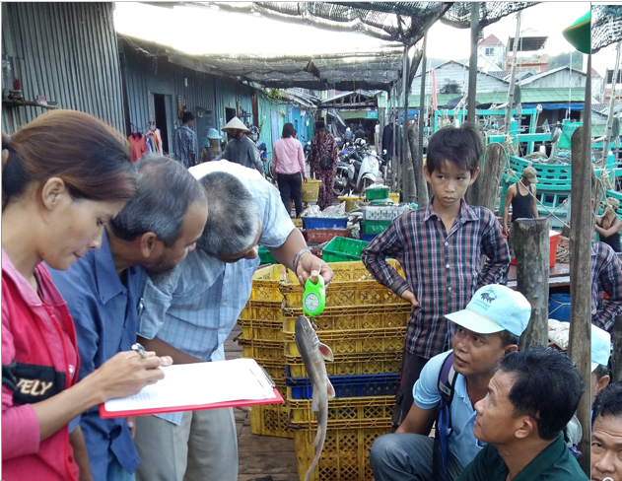
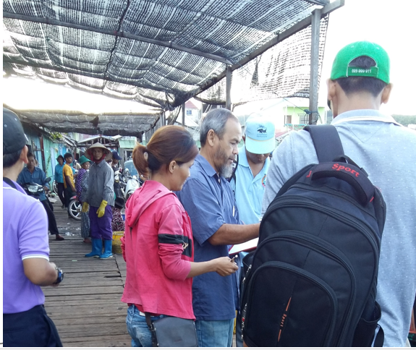

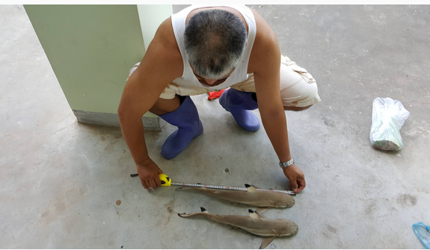
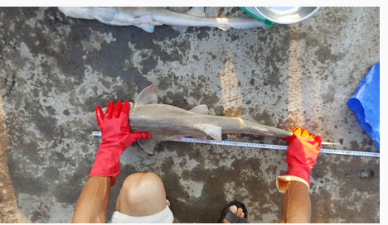

Picture 2: enumerator analysed taxonomy on shark species

